Installation Guide:
ALT-YD-CD00-LED-BK-(All)
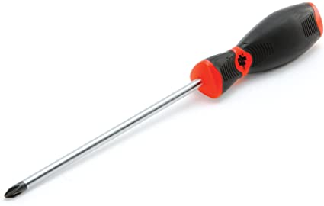
Tools Needed:
- Phillips Screwdriver

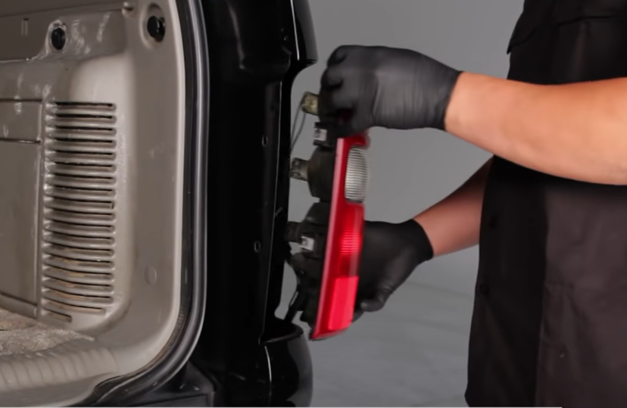
- Unseat tail light.
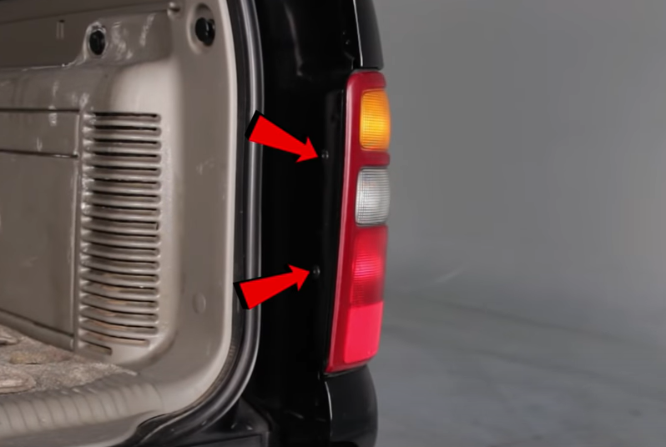
- Remove (2x) phillips screws.

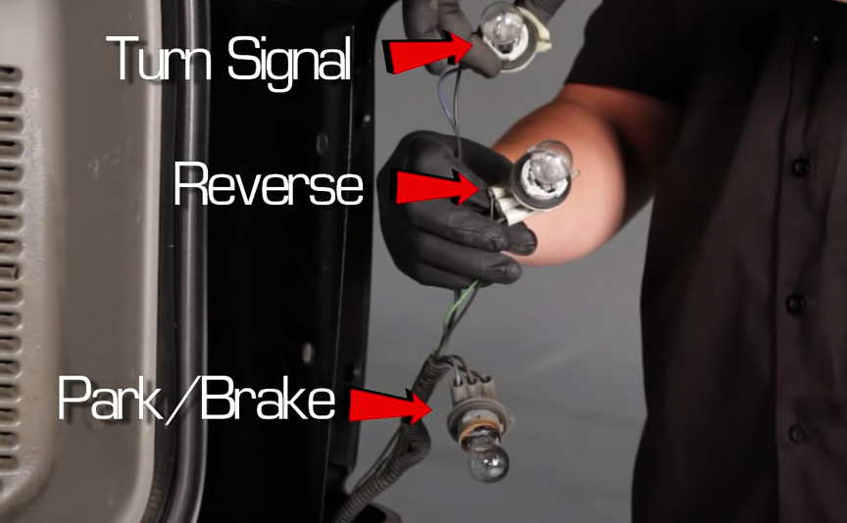
- Remove turn signal and park/brake light bulbs from socket. (Make sure to not touch bulb with bare hand)
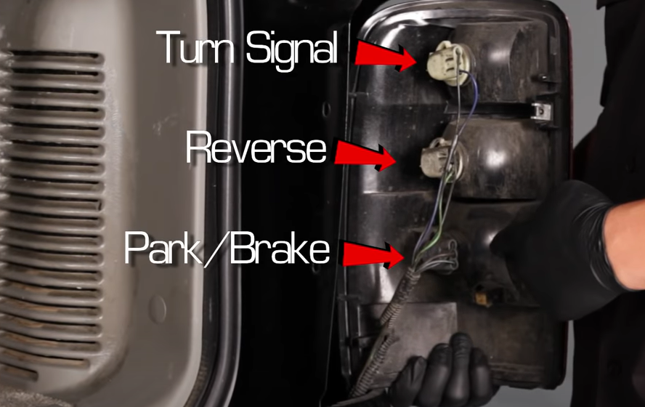
- Remove all bulb sockets from tail light.

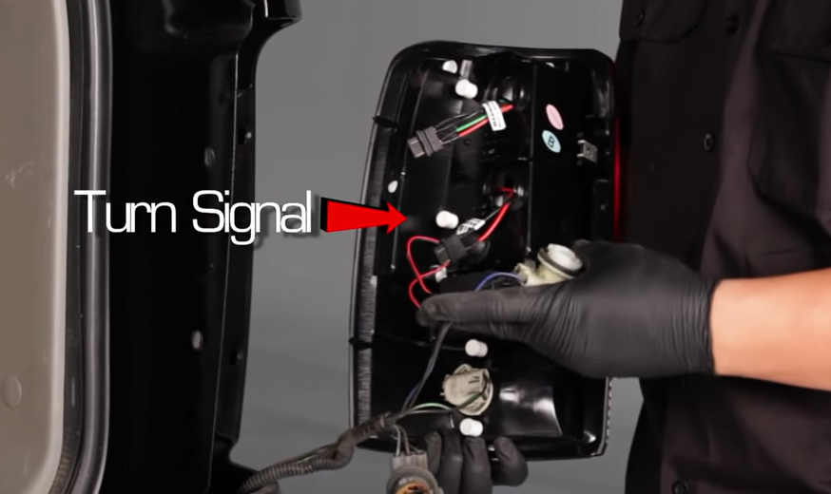
6. Locate 2-wire turn signal socket. Install into center plug on Spyder tail light. Plug in socket insert making sure to align black wire to black wire of insert.
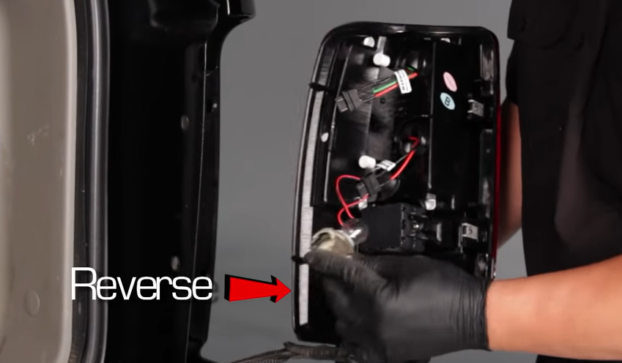
- Install reverse light socket into Spyder tail light.

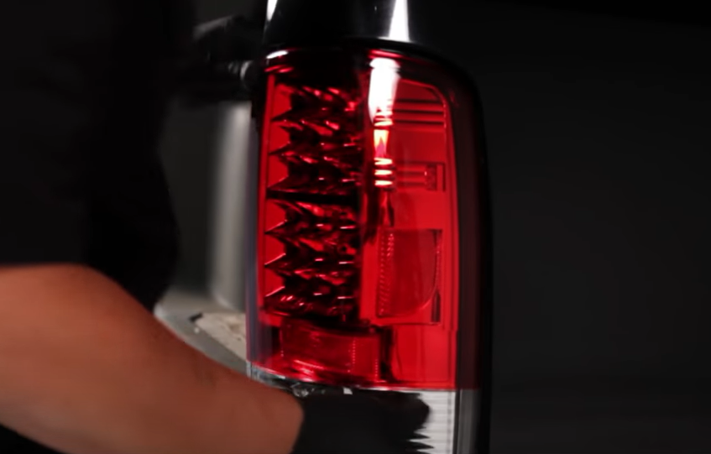
- Seat Spyder tail light making sure not to pinch wires.
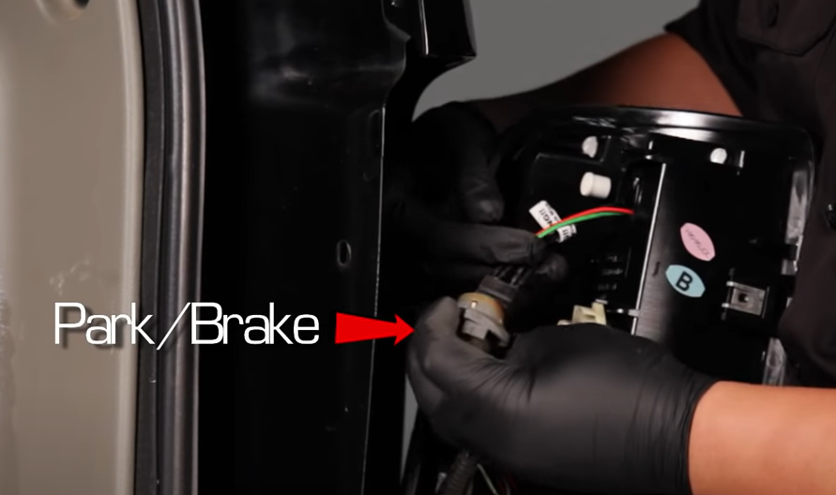
- Install top socket insert into park/brake socket. Make sure to align black wire of socket to black wire of insert.

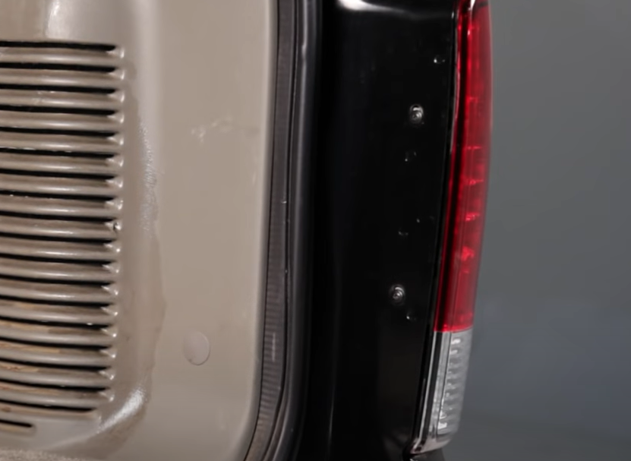
- Reinstall (2x) phillips screws.
9. Turn on lights and confirm all functions are working properly. You have successfully completed the install of your new Spyder tail lights.

For further help with installation, please watch our installation video. Follow the direct link below to our YouTube channel for more information:
http://www.youtube.com/watch

DISCLAIMER
Spyder Auto Installation Guide is not liable for damages, injuries, and death while installing the product. This is intended to be an installation guide, to reduce installation time. We have no responsibility for improper installation. If you do not know how to install, please have a professional install it.

