Installation Guide:
ALT-YD-CCO15-LED-(All)
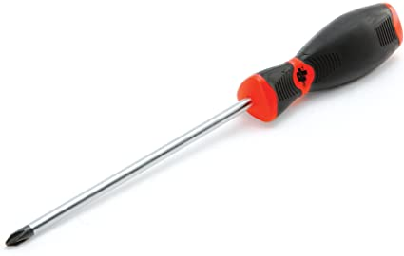
Tools Needed:
- Phillips Screwdriver

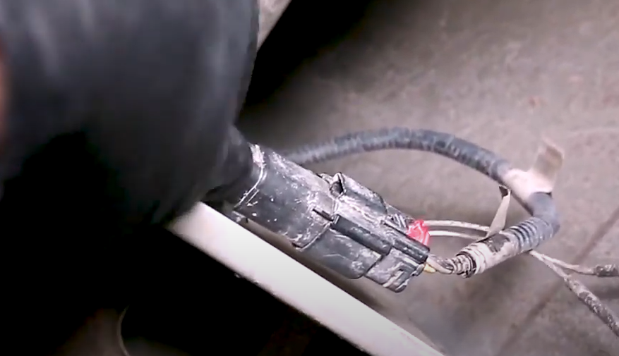
- Slide connector off of the holder and disconnect harness.
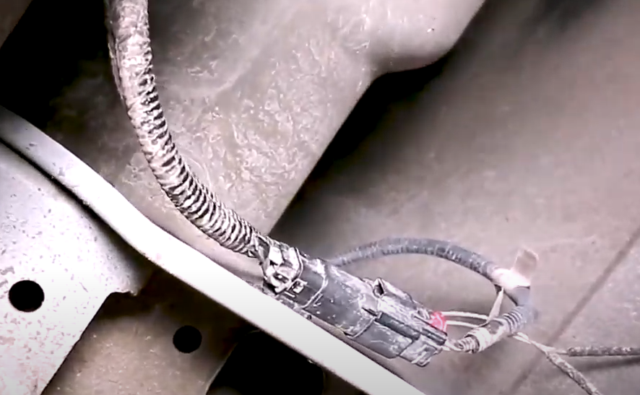
- Locate wire harness plug under rear of vehicle.

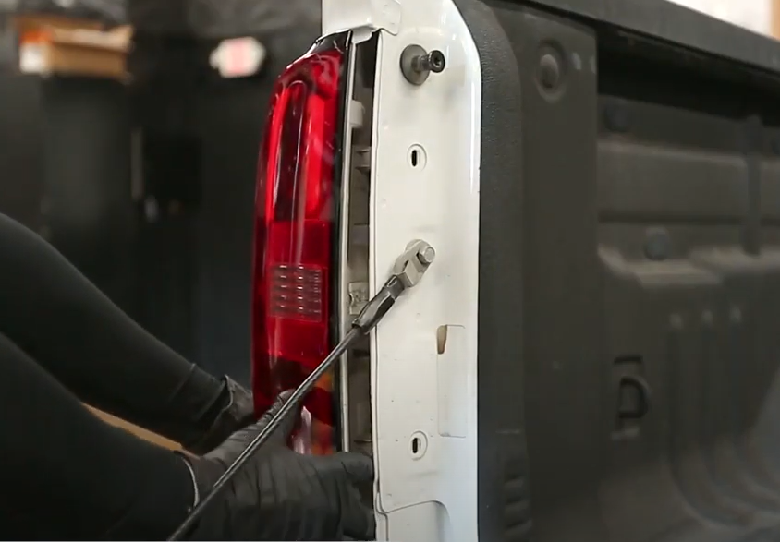
- Unseat tail light.
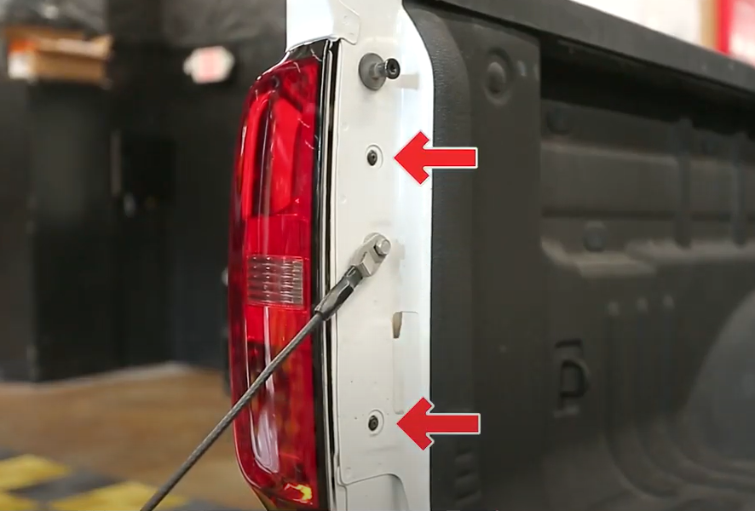
- Locate and remove (2x) phillips screws.

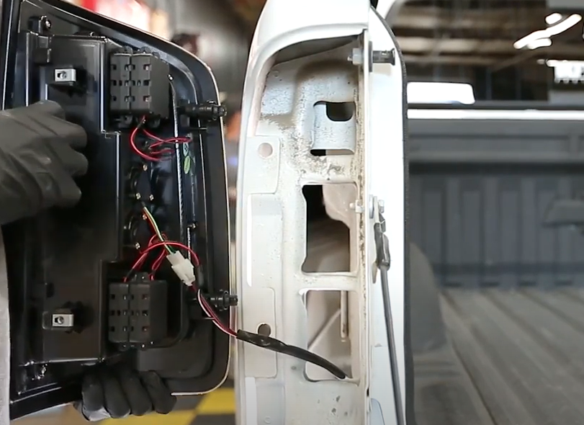
6. Feed Spyder tail light harness into the truck using the same wire routing.
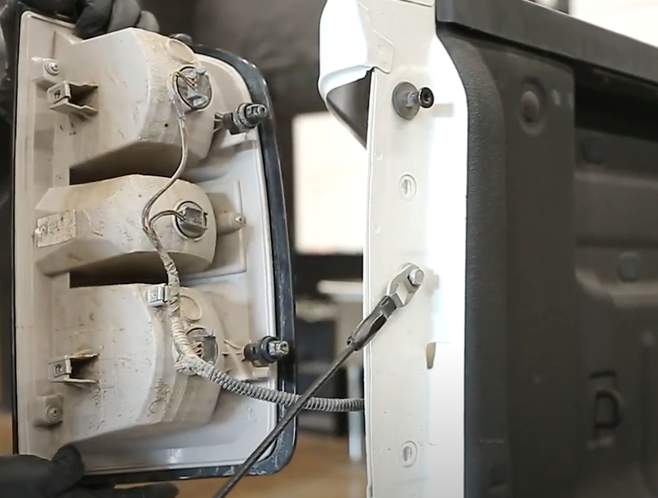
- Remove tail light and wiring harness.

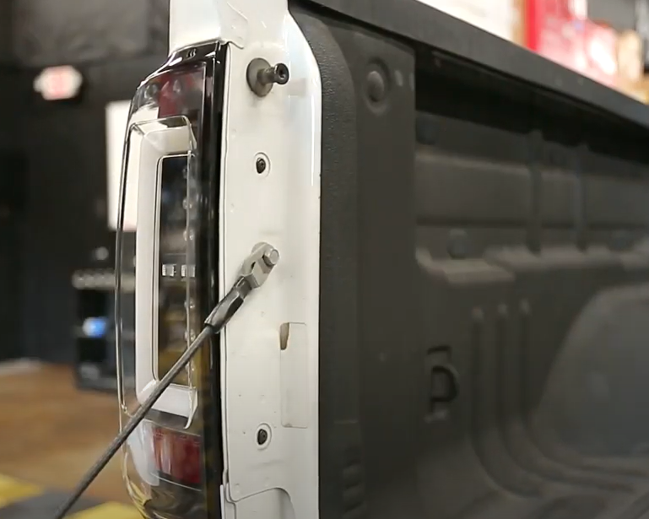
- Reinstall (2x) phillips screws.
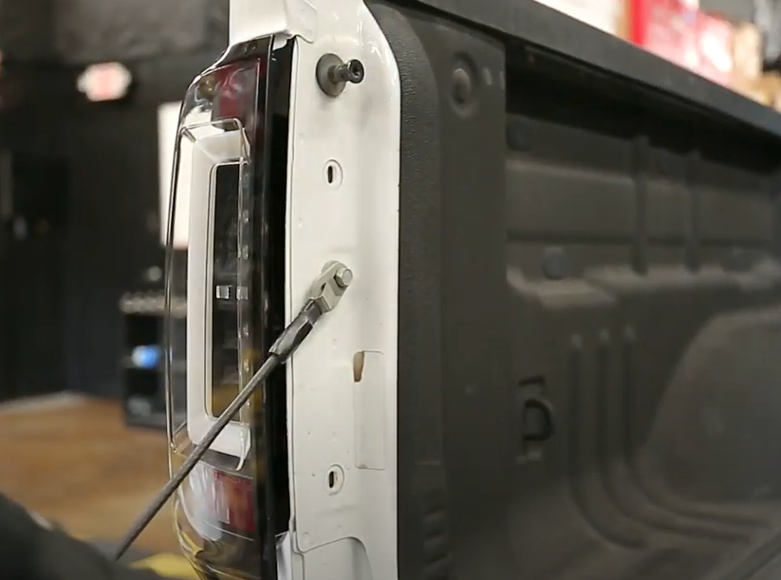
- Seat Spyder tail light making sure not to pinch harness.

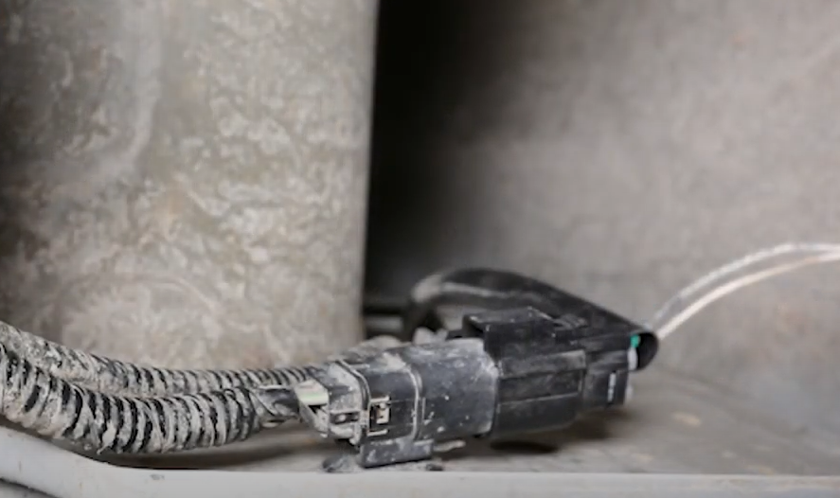
- Connect Spyder tail light and seat plug onto holder.
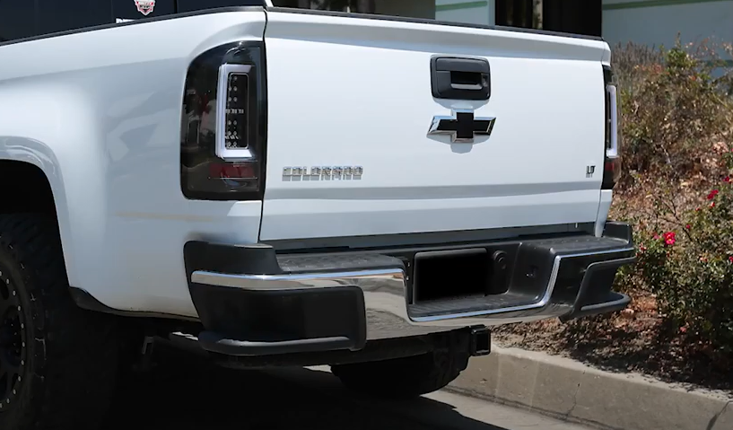
10. Turn on lights and confirm all functions are working properly. You have successfully completed the install of your new Spyder tail lights.

For further help with installation, please watch our installation video. Follow the direct link below to our YouTube channel for more information:
http://www.youtube.com/watch

DISCLAIMER
Spyder Auto Installation Guide is not liable for damages, injuries, and death while installing the product. This is intended to be an installation guide, to reduce installation time. We have no responsibility for improper installation. If you do not know how to install, please have a professional install it.

