Installation Guide:
ALT-YD-CAV02-LED-BK-(All)
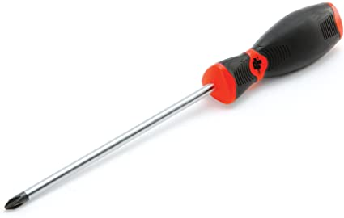
Tools Needed:
- Phillips Screwdriver

- Unseat tail light.
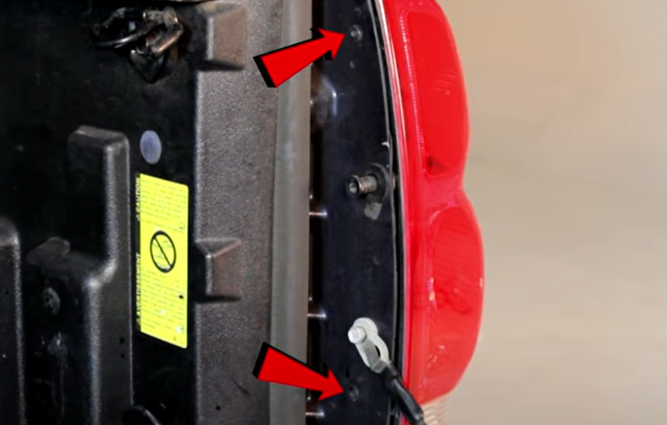
- Remove (2x) phillips screws securing tail light to the body.

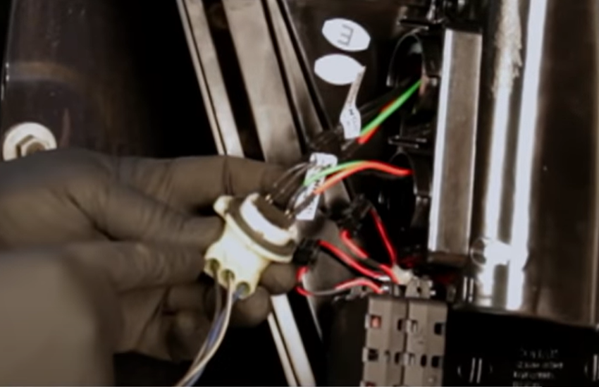
- Install center bulb insert into center socket making sure to match black wire side of insert to black wire side on socket.
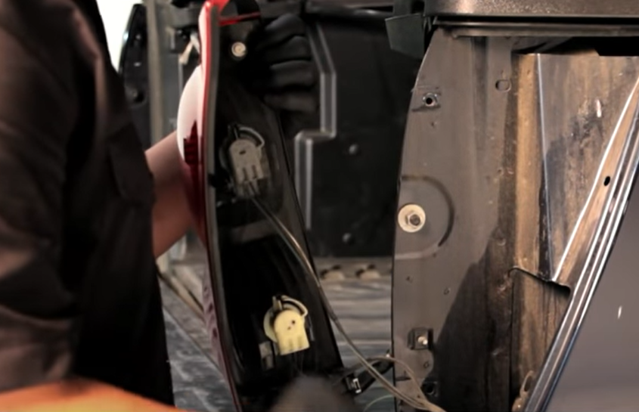
- Remove brake, park and reverse sockets. (Never touch bulb with bare hands)

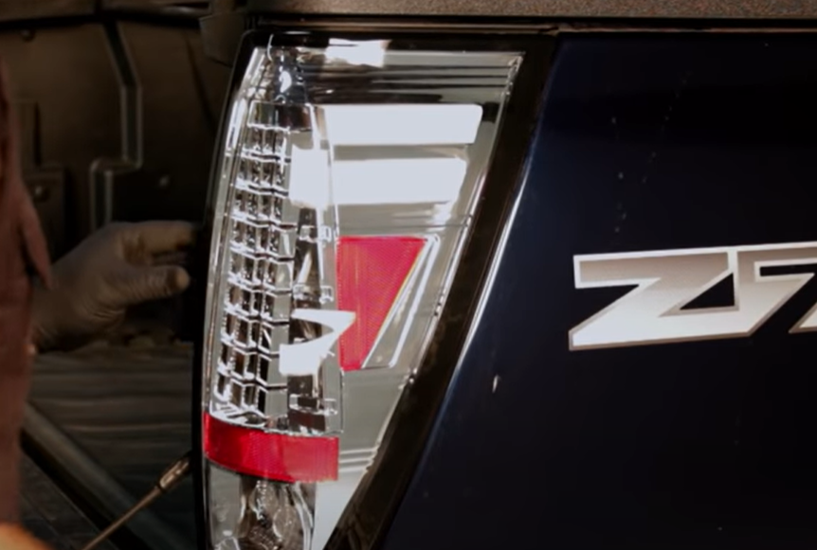
- Seat Spyder tail light taking caution not to pinch wires.
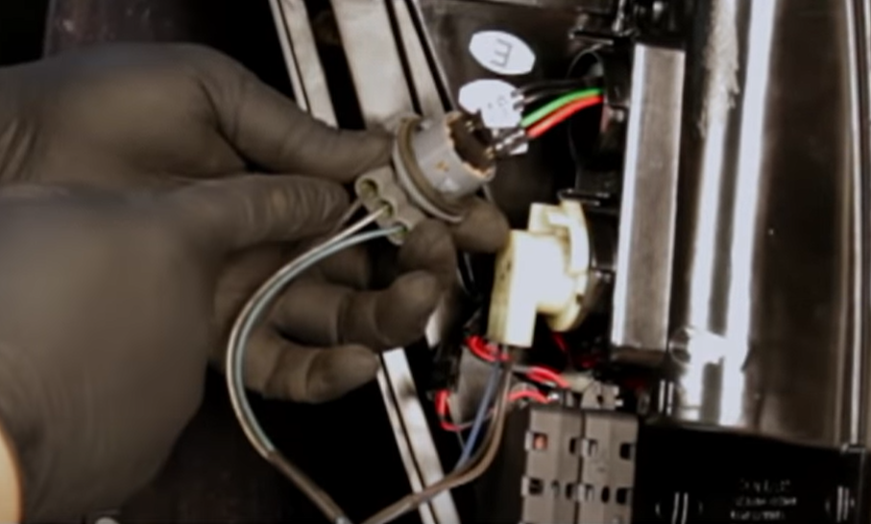
- Install upper bulb insert into upper socket making sure again to match black wire side of insert to black wire side on socket.

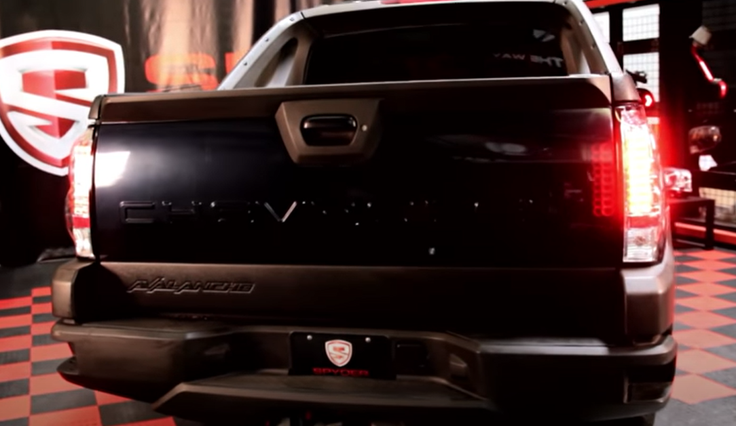
8. Turn on lights and confirm all functions are working properly. You have successfully completed the install of your new Spyder LED tail lights.
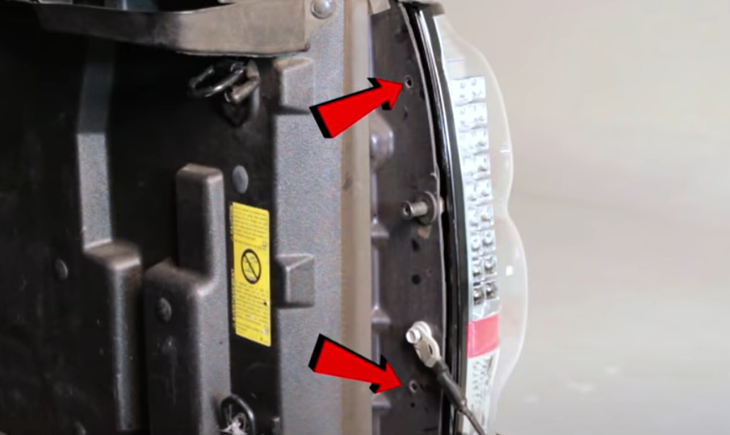
- Reinstall (2x) phillips screws securing tail light to the body.

For further help with installation, please watch our installation video. Follow the direct link below to our YouTube channel for more information:
http://www.youtube.com/watch

DISCLAIMER
Spyder Auto Installation Guide is not liable for damages, injuries, and death while installing the product. This is intended to be an installation guide, to reduce installation time. We have no responsibility for improper installation. If you do not know how to install, please have a professional install it.

