

**Installation Guide:**

ALT-YD-C305-LED-(All)

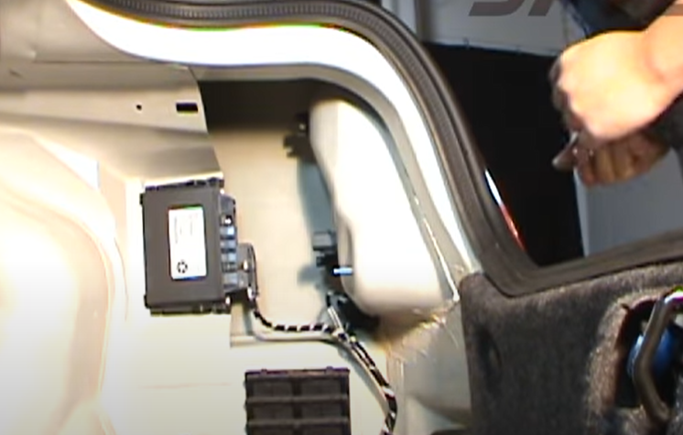

1. Pull back carpet lining to access tail light.

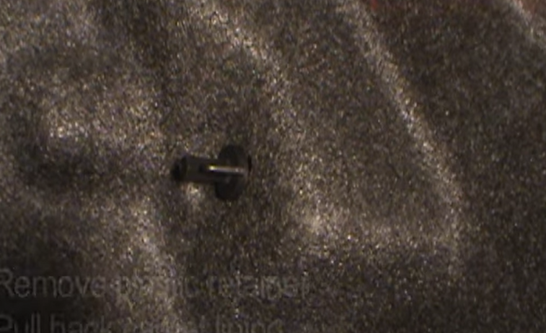

1. Remove thumb screw located behind the tail light.

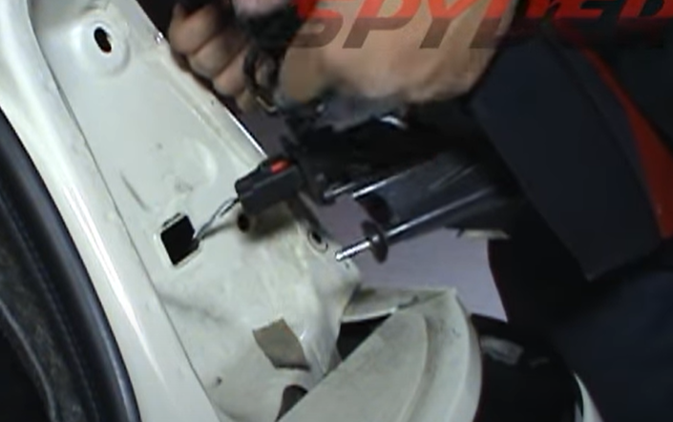

1. Unseat tail light.

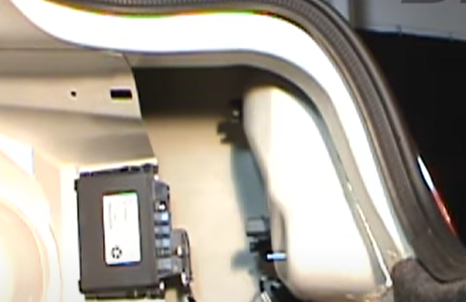

1. Remove (2x) thumb screws that secure tail light to the body.

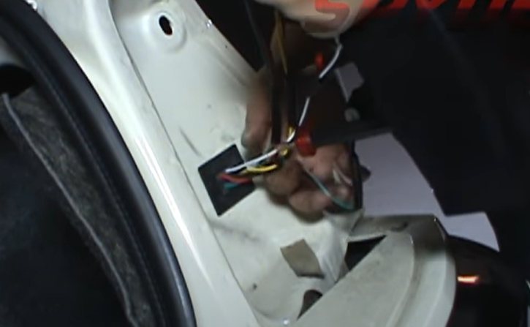

1. Connect Spyder tail light and secure rubber grommet.

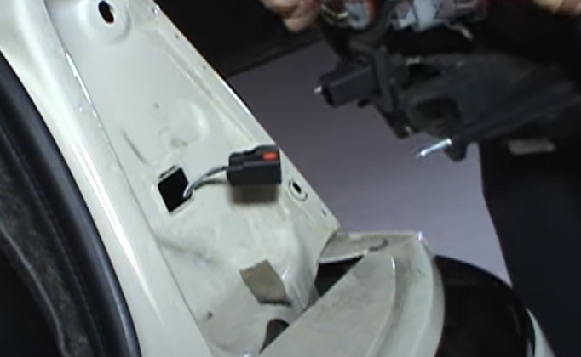

1. Disconnect tail light harness.

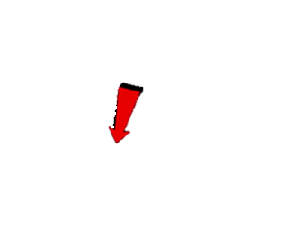





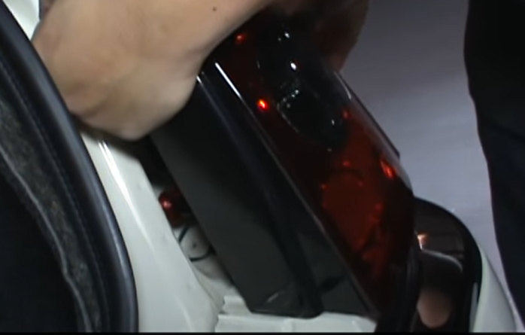

1. Seat Spyder tail light making sure not to pinch harness.

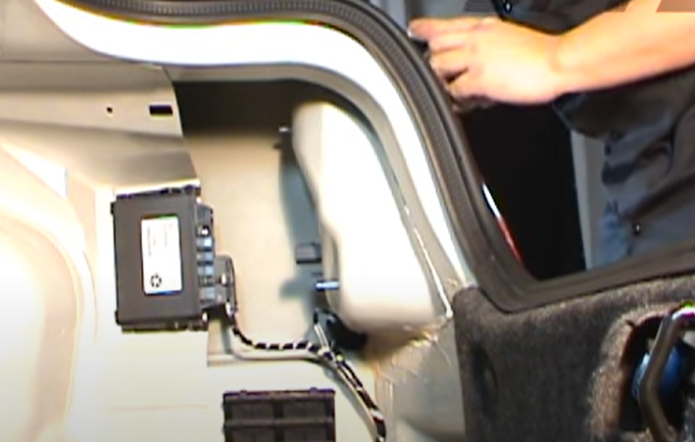

1. Reinstall (2x) thumb screws that secure tail light to the body.



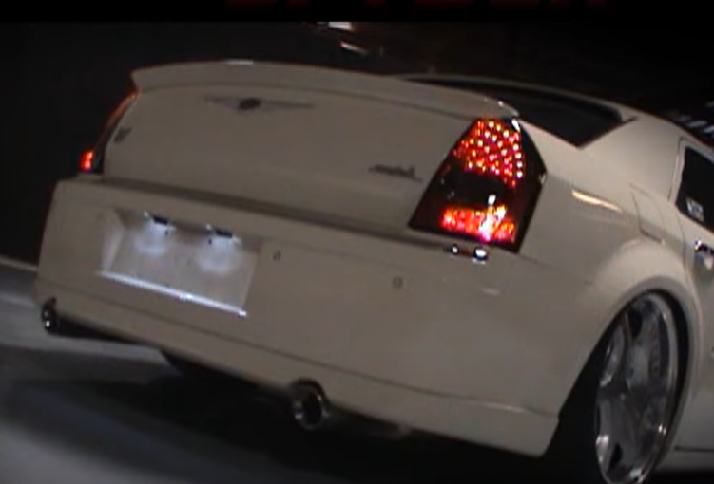

10. Turn on lights and confirm all functions are working properly. You have successfully completed the install of your new Spyder LED tail lights.

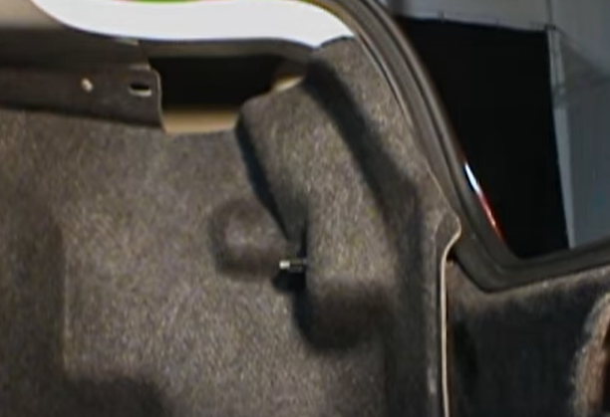

9. Reinstall carpet and (1x) thumb screw to secure carpet.



For further help with installation, please watch our installation video. Follow the direct link below to our YouTube channel for more information:

http://www.youtube.com/watch

**DISCLAIMER**

Spyder Auto Installation Guide is not liable for damages, injuries, and death while installing the product. This is intended to be an installation guide, to reduce installation time. We have no responsibility for improper installation. If you do not know how to install, please have a professional install it.