Installation Guide:
ALT-YD-ATT07-LED-(All)
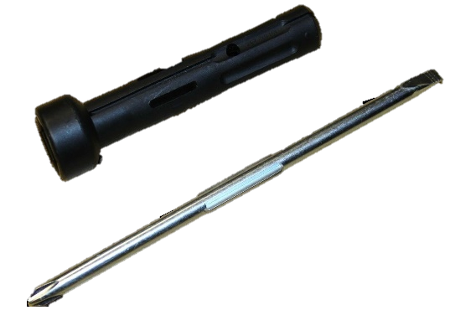
Tools Needed:
- Factory Multi Tool

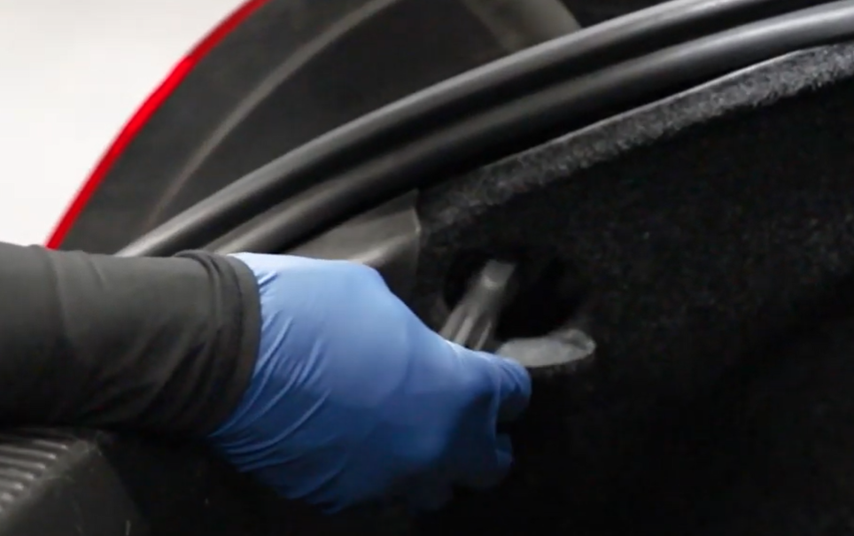
- Using handle of multi tool remove (x1) retaining screw.
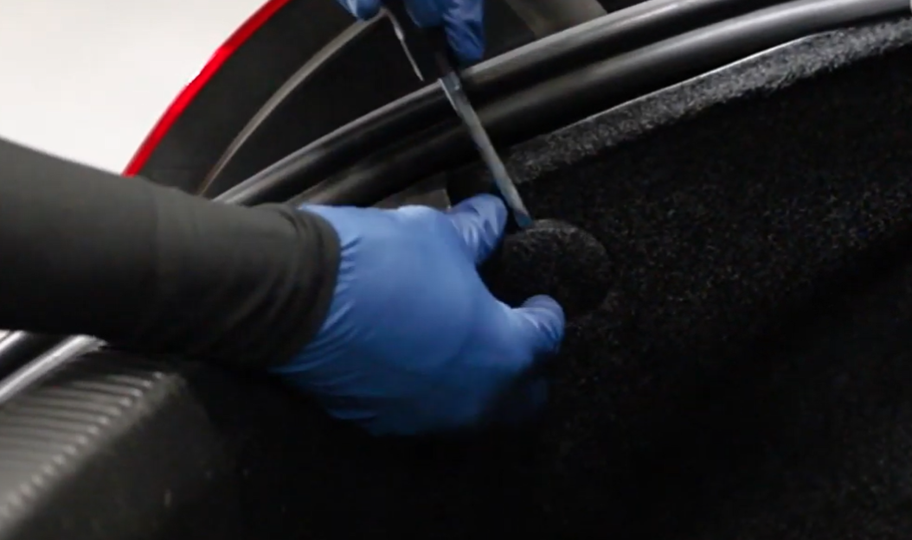
- Use the flat head to remove the round cover.

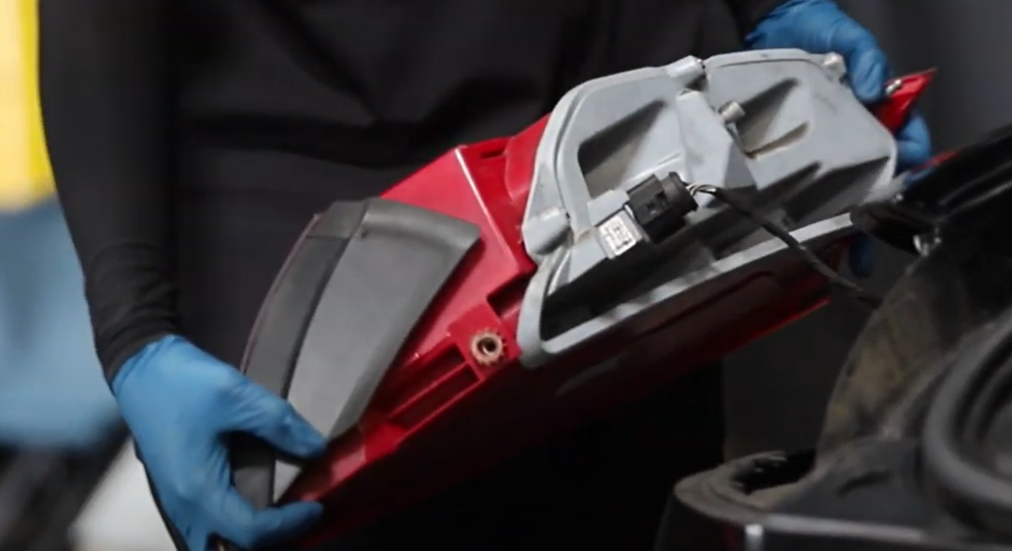
- Disconnect outer tail light harness.
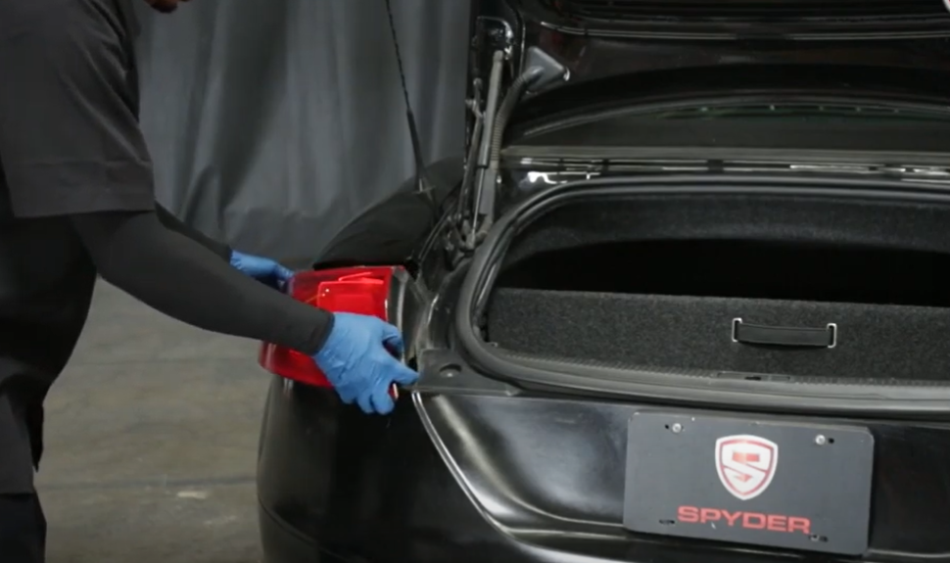
- Unseat outer tail light.

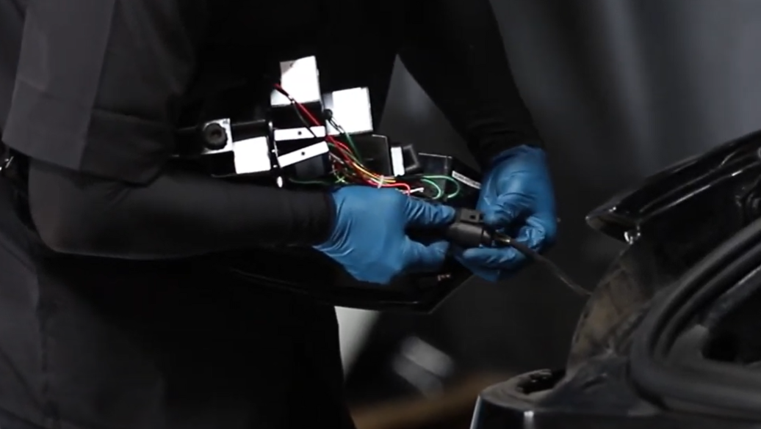
5. Connect wire harness to Spyder tail light.
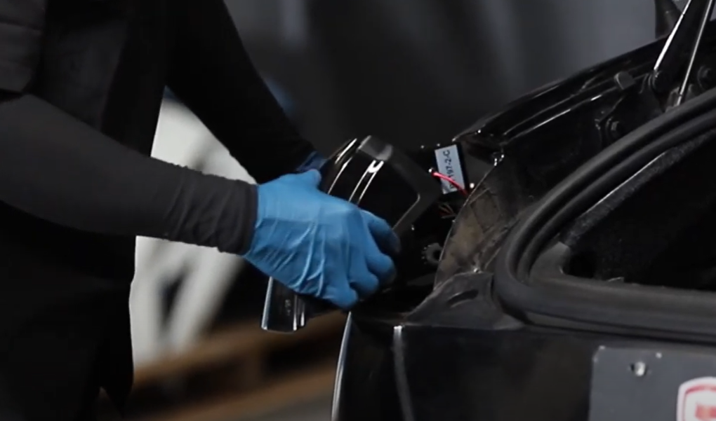
6. Make sure inner side of tail light slides over body panel.

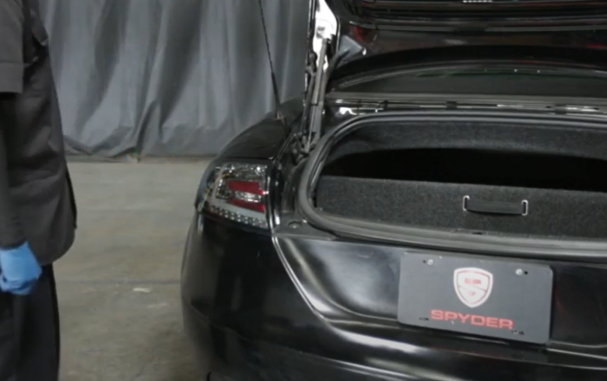
7. Push firmly on upper outside of tail light to snap in tail light.
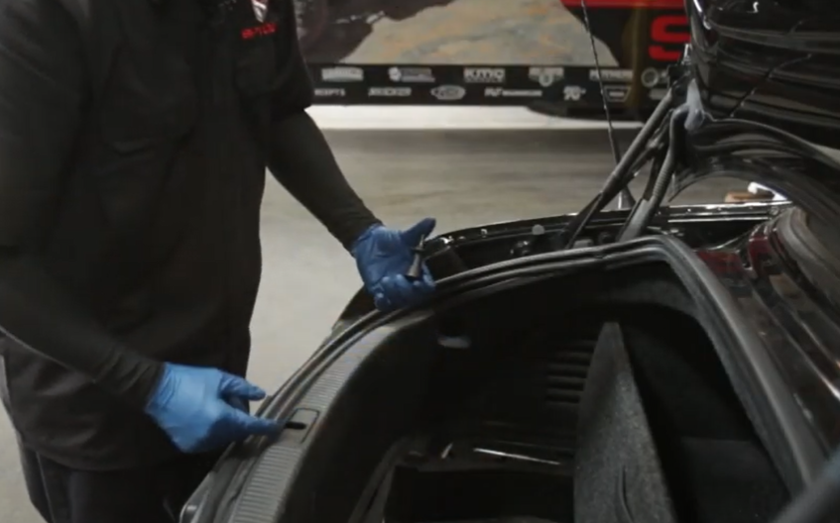
8. Reinstall retaining screw using multi tool.

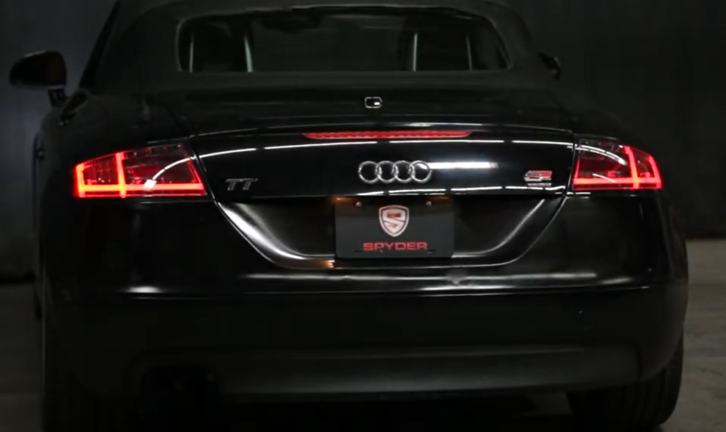
10. Turn on lights and confirm all functions are working properly. You have successfully completed the install of your new Spyder LED tail lights.

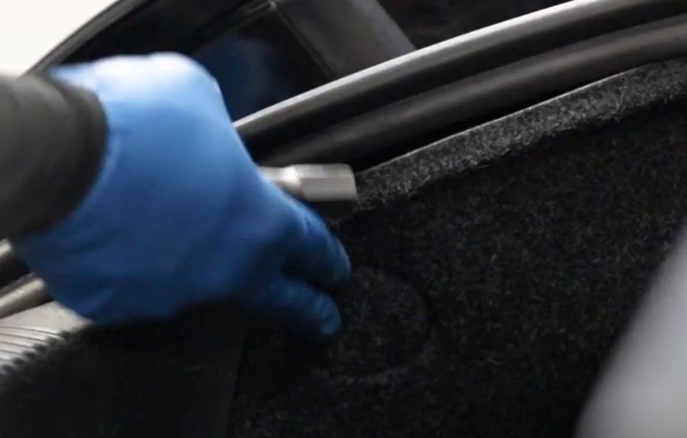
9. Close round cover.

For further help with installation, please watch our installation video. Follow the direct link below to our YouTube channel for more information:
http://www.youtube.com/watch

DISCLAIMER
Spyder Auto Installation Guide is not liable for damages, injuries, and death while installing the product. This is intended to be an installation guide, to reduce installation time. We have no responsibility for improper installation. If you do not know how to install, please have a professional install it.

